Key Note Speaker

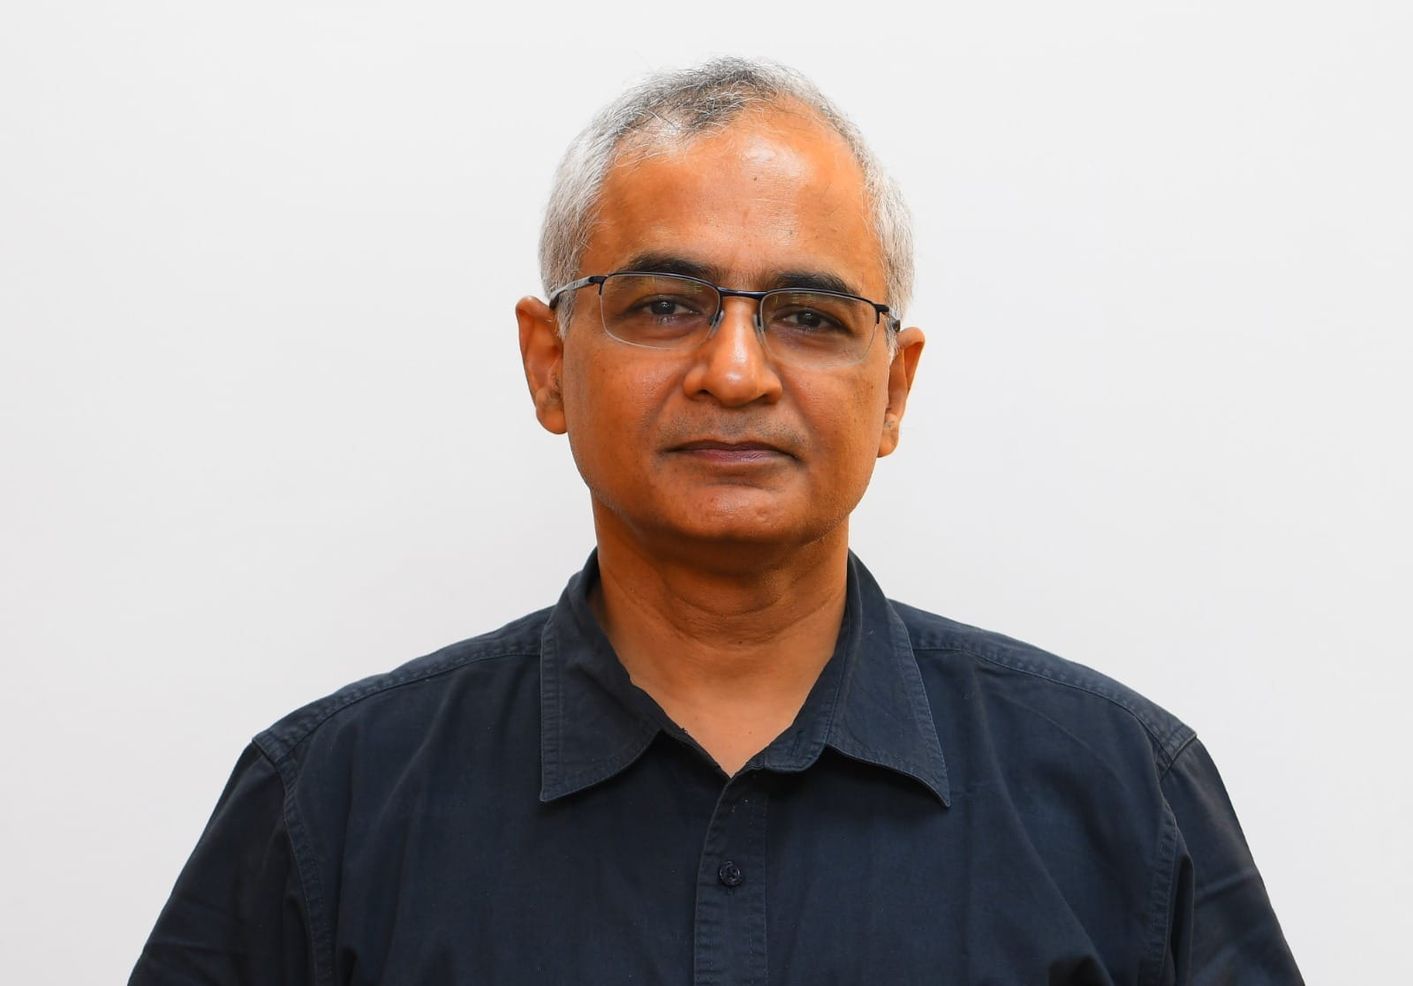

**Dr. Neeraj Mittal, IAS Secretary, Department of Telecommunications, Government of India**

**Profile :**

Dr. Neeraj Mittal, a senior IAS officer of the Tamil Nadu cadre, is the Secretary, Department of Telecommunications (DoT). An alumnus of IIT Kanpur, he holds a B.Tech in Electrical Engineering, an MBA from Cranfield University (UK), and a Ph.D. in Management Information Systems from The Ohio State University (USA). Dr. Mittal combines deep technical expertise with policy and institutional leadership. His career spans diverse roles: Principal Secretary (IT), Government of Tamil Nadu; CMD, TUFIDCO; MD & CEO, Tamil Nadu Industrial Guidance & Export Promotion Bureau; and Senior Advisor at the World Bank Group, Washington DC. He has been a driving force in digital governance, investment facilitation, and infrastructure financing, attracting global investors to India and advancing technology-led reforms. At DoT, he is shaping the vision for Telecom as the backbone of Digital Public Infrastructure, anchoring initiatives like the Digital Twin with AI-Driven Insights (Sangam). His keynote will spotlight how telecom intelligence, AI, and systemic foresight can transform India’s infrastructure planning — enabling it to be more data-driven, resilient, and future-ready

**Moderator**

**Shri Sunil Bajpai - Former Additional Member (Mechanical Engineering), Railway Board; Former Principal Advisor, TRAI**

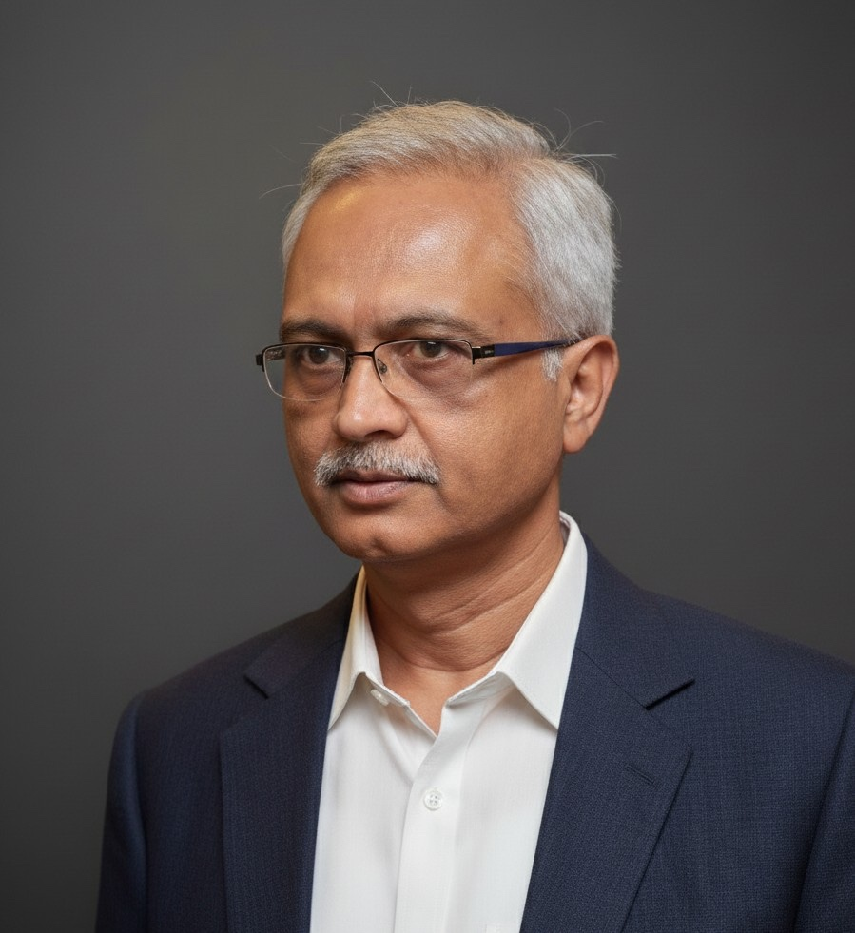

Profile :

A senior officer of the Indian Railway Service of Mechanical Engineers (IRSME, 1985 batch), Shri Bajpai has served at the apex of the Railway Board as Additional Member (Mechanical Engineering), guiding national policy and operations for India’s largest transport system. His career spans leadership roles as Divisional Railway Manager (Trivandrum), Chief Mechanical Engineer (Planning), Southern Railways, and General Manager (ICMS), CRIS, where he drove technologyenabled reforms. Later, as Principal Advisor at TRAI, he advanced policies on quality of service and IT, strengthening citizen trust in telecom. An avid reader and systems thinker, he brings a rare combination of transport expertise, regulatory insight, and systemic vision to moderate the Digital Twin dialogue.

PANEL SPEAKER 1

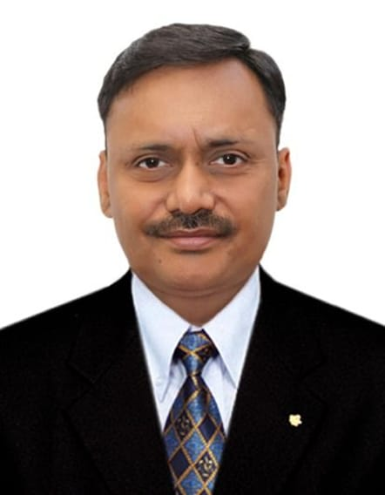

Dr. Amit Kumar Jain Director (Operations & Services), Delhi Metro Rail Corporation (DMRC)

Profile

Dr. Jain, an officer of the Indian Railway Traffic Service, serves on the Board of DMRC as Director (Operations & Services) and CEO of DMIL, overseeing operations across the National Capital Region. He has over two decades of experience in rail and metro operations, safety, multimodal integration, and transport economics with earlier roles in Indian Railways and CRIS.

A strong believer in the role of telecom data for transport planning, Dr. Jain has consistently championed its use to improve forecasting and system efficiency. He co-authored books titled “LEAD SMART in the AI ERA” (2025), which Informs us about volatile, uncertain, complex and ambiguous (VUCA) world amplified by artificial intelligence (AI) requiring mitigation of risks, including fake data, cyberattacks and frauds, and book on “Intelligent Transport Systems” (2018), which anticipated the impact of 5G, ITS, and telecom-enabled planning in both road and rail sectors. His thought leadership and hands-on operational perspective make him a vital voice for embedding telecom intelligence and Digital Twins into mainstream transport planning.

PANELIST 2

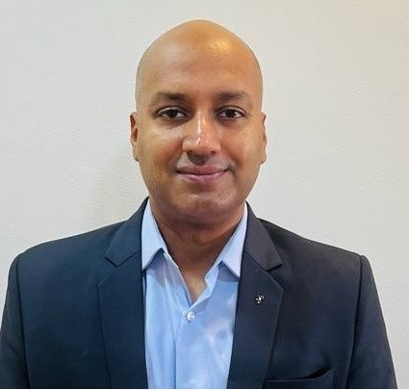

Mr. Rahul Joshi Head - Network Analytics & Automation, Reliance Jio

Profile :

Rahul Joshi leads the national Analytics and Automation function at Reliance Jio Mobility. He is responsible for building one of the largest AI-ready data ecosystems in the telecom sector, processing over 300 billion events daily across petabyte-scale datasets. His work focuses on creating scalable data platforms, correlating diverse data streams, and generating high-impact mobility insights using advanced geospatial and temporal analytics frameworks across India’s largest network infrastructure. He has spearheaded the development of digital twins and real-time data products that power network optimization, customer experience improvement, urban planning, and transport analytics. His team designs AI-ready pipelines and automated intelligence systems including applications, dashboards, and scoring frameworks, that empower Jio’s strategic vision and enable democratized intelligence at scale.

PANELIST 3

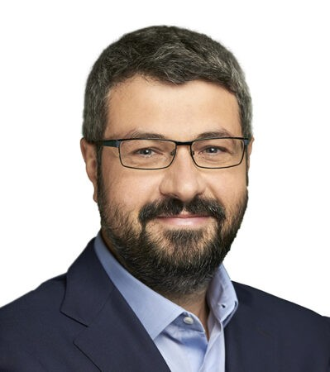

**Dr. Simone Redana Director, Head of Architecture & Automation Research, Nokia (Germany)**

Profile :

Dr. Redana leads a global team of over 90 researchers and standards experts at Nokia, shaping the future of network automation, AI/ML integration, and next-generation telecom architectures. He has played a key role in 5G trials in Japan and Germany, focusing on URLLC, time-sensitive communication, and industrial applications. Actively contributing to 3GPP, ORAN Alliance, ETSI MEC, and ZSM, he brings insights from international standardization and real-world pilots. At this roundtable, he anchors the discussion on advanced simulation, AI-driven networks, and lessons from global telecom research for Digital Twins.

Panelist 4

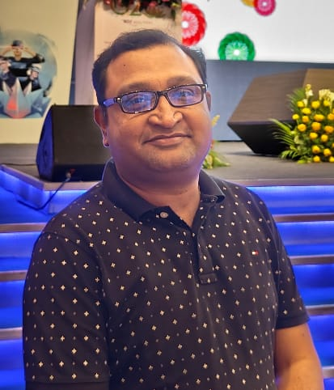

**Mr. Sagar Mathur Vice President & Head – Regulatory Operations, Bharti Airtel**

**Profile :**

Sagar Mathur is Vice President & Head - Regulatory Operations at Bharti Airtel Ltd., where he leads efforts to ensure regulatory compliance and optimise operational processes across the organisation. He holds a Bachelor’s degree in Commerce and an MBA with a focus on Information Technology providing him with a diverse skill set on managing business, technology, and regulatory requirements in the telecom sector. Bringing over 22+ years of in-depth experience, he brings a wealth of expertise in key areas such as KYC, Security, Legitimate use of AI, Network Operations, Right of Way, Public Policy and Compliance Management. His deep understanding of regulatory dynamics and his leadership in circle operations management have made him the go-to expert for navigating complex legal and policy matters between the licensor, regulator and security agencies. His proven track record of managing cross-functional teams and streamlining operations has contributed to the successful implementation of major regulatory initiatives and operational improvement.

PANELIST 5

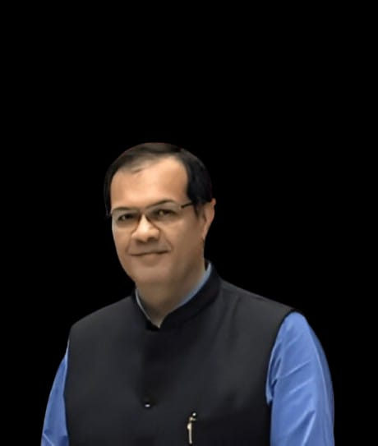

**Dr. Jaijit Bhattacharya President, Centre for Digital Economy Policy Research (C-DEP)**

**Profile** :

An economist and policy expert, Dr. Bhattacharya is known for shaping digital economy frameworks, incentive models, and infrastructure strategies. Formerly Head of the Centre for the Fourth Industrial Revolution (India), World Economic Forum, and Partner at KPMG India, he brings deep experience in linking technology to governance and economic sustainability. Currently leading C-DEP, he champions inclusive digital public infrastructure and data valuation models. At this roundtable, he anchors the discussion on the economic logic of Digital Twins and reward frameworks essential for long-cycle sustainability

PANELIST 6

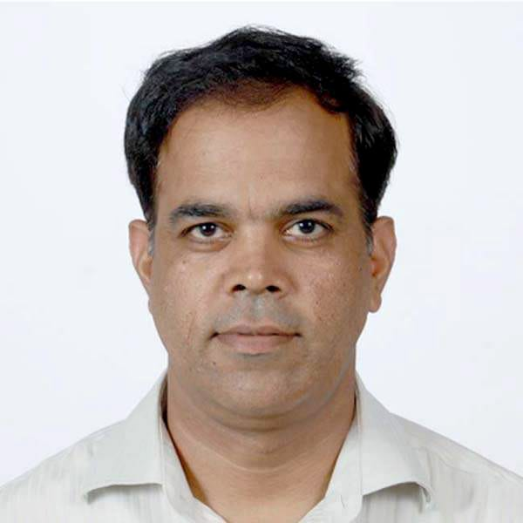

**Mr. Asit Kadayan Deputy Director General & Head – Digital Twin Unit, Department of Telecommunications (DoT)**

**Profile**

Mr. Kadayan leads the Digital Twin Unit at DoT, spearheading the Sangam Digital Twin with AI-Driven Insights Initiative. Under his leadership, the initiative has delivered the Delhi Metro PoC and advanced pilots for New Delhi Railway Station, Bengaluru corridors, and Jaipur Metro, showcasing the potential of telecom-derived mobility data, AI, and simulation in infrastructure planning. A career telecom officer, he has previously worked on QoS, AI/ML adoption, and regulatory innovation in both DoT HQ and TRAI. He brings a systems view of telecom as the sensing and semantic backbone for cross-sectoral Digital Twins, focused on making infrastructure planning more data-driven, participatory, and future-ready.